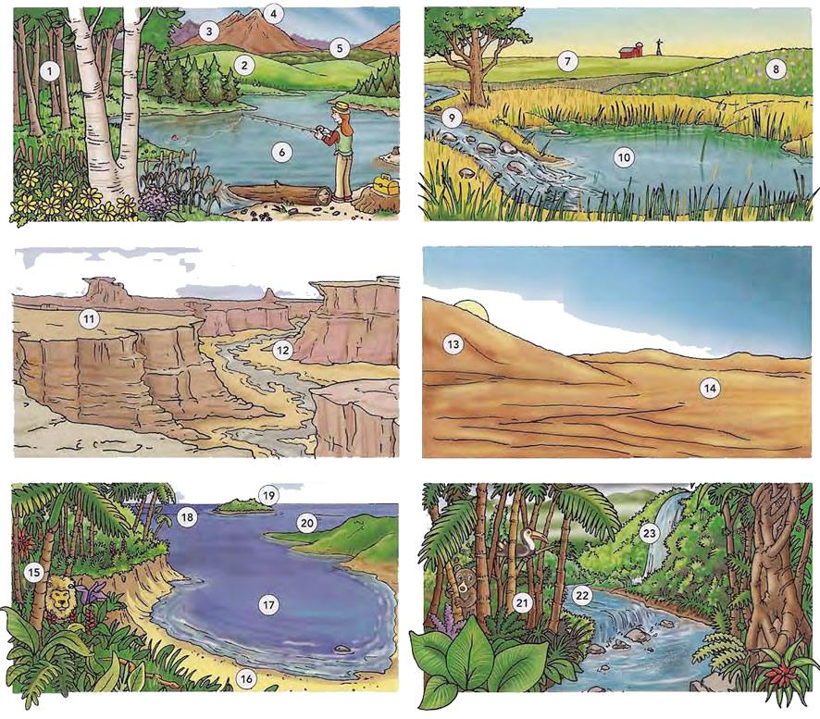

waterfall , stream , rainforest, woods, hill , mountain range , bay , ocean , jungle, dune , plateau , meadow, plains, valley , lake , mountain peak/summit, desert , Island , peninsula , seashore , pond ,